

TASK

Exploratory Data Analysis on the ‘Data Science Salaries 2023’ Dataset



Introduction
This EDA will analyse the ‘data science salaries 2023’ dataset. This dataset was extracted from Kaggle (source- Data Science Salaries 2023 💸 | Kaggle) . The initial analysis of this dataset describes 11 columns, including work_year, experience_level, employment_type, job_title, salary, salary_in_usd, employee_residence, remote_ratio, company_location and company_size. There are 3755 entries in total, consisting of int64 and object datatypes, therefore the dataset can be described as numerical and categorical. The describe method was also applied to show the statistical values of the numerical columns.

DATA CLEANING

The duplicated rows were removed from the dataset, there were 1171 duplicated rows in total. There is no missing data according to the isnull().sum() method. This helps reduce the size of a large dataset. As this data is revolves around salaries and considers various countries, the ‘salary’ and ‘salary_currency’ columns have been removed. As the currency will be different for each country, this EDA will be using a standard form of salary from the ‘salary_in_usd’ column. Also ‘employee-residence’ will be removed as it will not contribute any valuable insight into the salary and there is the ‘company_location’ columns which variables can be used instead. The nunique() method revealed that the ‘salary_in_usd’ (1035), ‘company_location’ (72) and ‘job_title’ (93) have many unique values and will be explored by a certain number of values in the data visualisation.

The ‘experience _level’, ‘employment_type’ and ‘remote_ratio’ variables were non-descriptive; therefore, these were replaced so the reader could have a better understanding of the information provided. The scatterplot below visualises outlier in the dataset , the ‘salary’ column has the highest proportion but as we will not be working with this variable, there is no need to remove any outliers. Lastly, all datatypes of the remaining variables are correct, so no changes are needed.
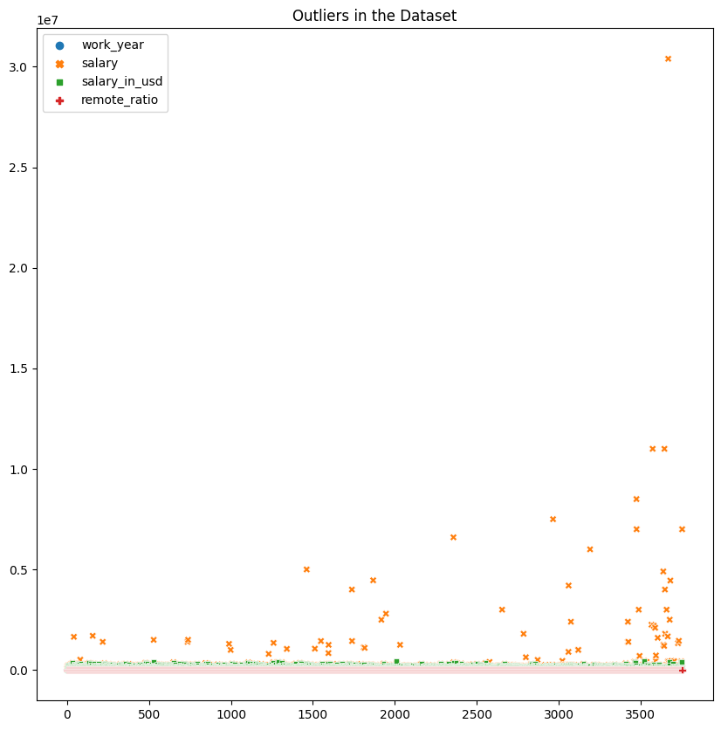

MISSING DATA

No missing data.

DATA STORIES AND VISUALISATIONS

The focus of this EDA will be to visualise the impact the variables, most notably the salaries, present in this dataset have impacted the data science job sector from 2020-2023. To begin, the pie chart below demonstrates the percentage of each experience level present.

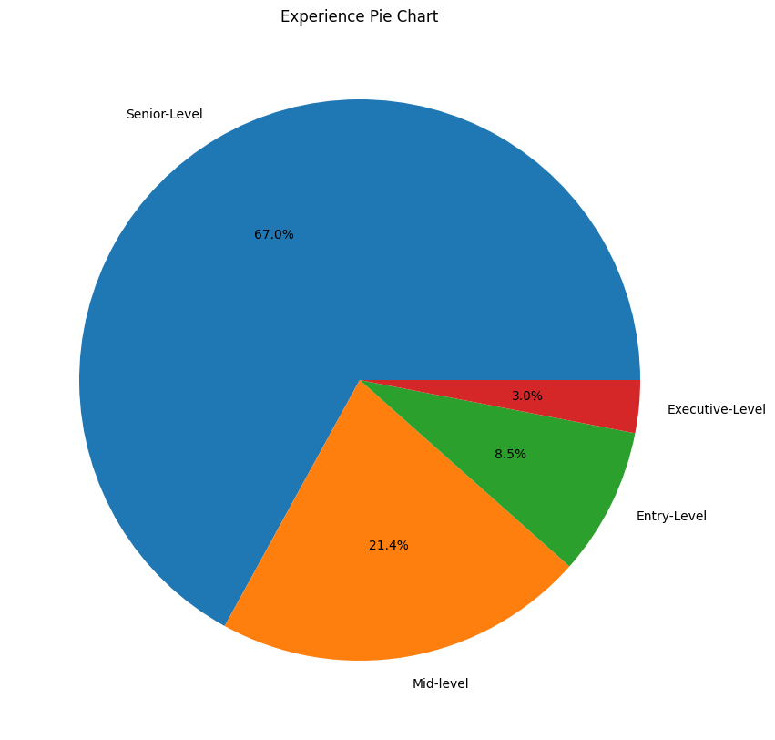

The senior-level professional is by far the most prominent making up 67% of the data , this is followed by mid-level professionals at 21.4%, entry-level professionals at 8.5% and executive-level professionals at 3.0%. The assumption we can make based on this data is that there appears to be a significant number of professionals who have worked their way up to senior positions but only a few ever get to be at the executive level, perhaps due to lack of available roles within companies. There is a smaller percentage of mid-level and entry-level individuals which could mean that there has been less demand for employing graduates and not enough jobs left for middle-level employees to progress to the next level. This pattern could be explained by looking at the work_year variable to see there are any changes in employment withing the sector.

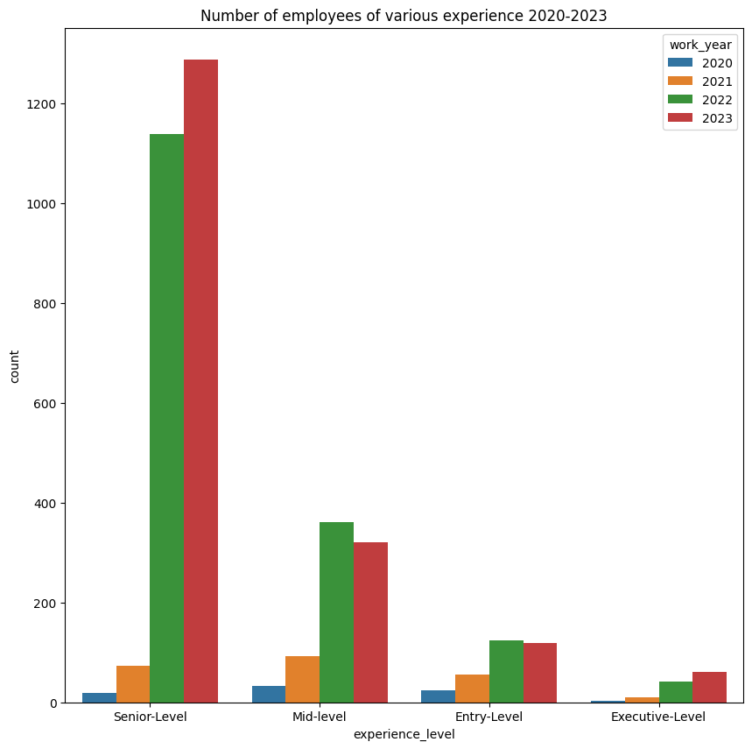
The countplot represents numbers of employees of different levels from 2020-2023. In the earlier years, 2020-2021, there is a severe lack of employment at all levels compared to the later years. Then there is a significant increase in the number of employees in 2022 and 2023, particularly at the senior level. Entry-level and mid-Level count appear to have decreased a bit in 2023. The sudden surge in 2022-2023 could represent an increase in job availability as data science continues to grow as a sector and becomes a viable career option for the future. Another explanation could be that companies are employing individuals with greater experience after COVID as business activity would see an increase.

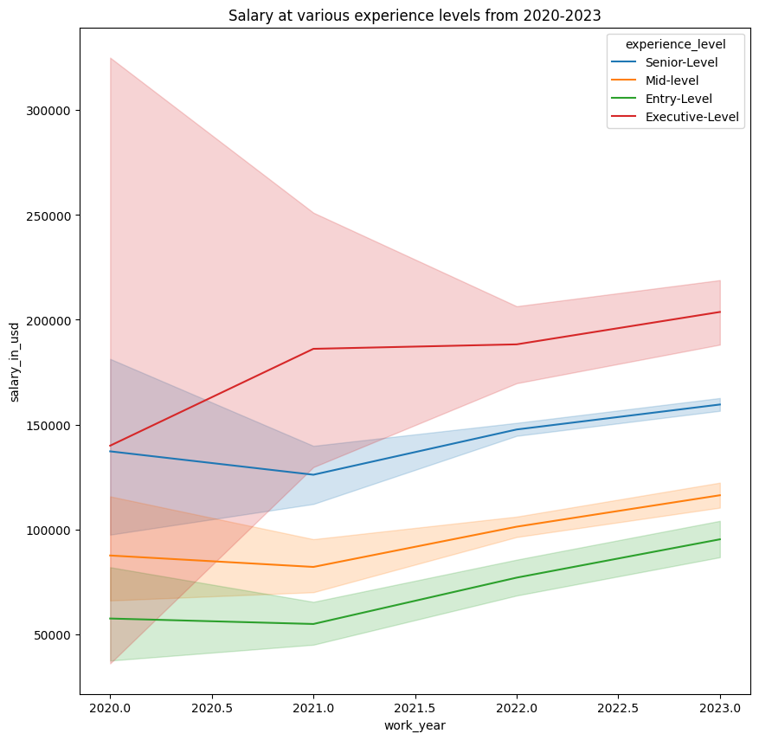

This lineplot describes the fluctuations of salaries between employment level. For Entry-level, mid-level and senior-level employees see a decrease in salary from 2020- 2021, however for the executive-level salary rises during that time. After the start of 2021, the salaries of the entry entry-level, mid-level and senior-level employees increase but the executive-level salary decreases. Moreover, all salaries continue to increase slightly from 2022 onwards. The salary level decrease in 2020-2021 could be explained by the need to downsize staff during COVID or simply reduce salaries to cut costs.

The next variable to be looked at will be the employment type, the table below shows the number of employees per type within the dataset.

Full-Time 3718
Part-Time 17
Contract 10
Freelance 10

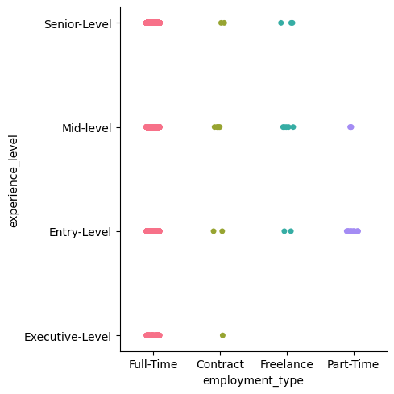

The table shows that full time is the preferred employment type for the sector. There is little difference between part-time, contract and freelance which are all significantly lower in employment preference. The catplot depicts the usual employment type between experience levels. Entry and mid-level employment seems be range between all types of employments, whereas senior level employment does not include part time contracts, and executive level only includes full time and contracted work.

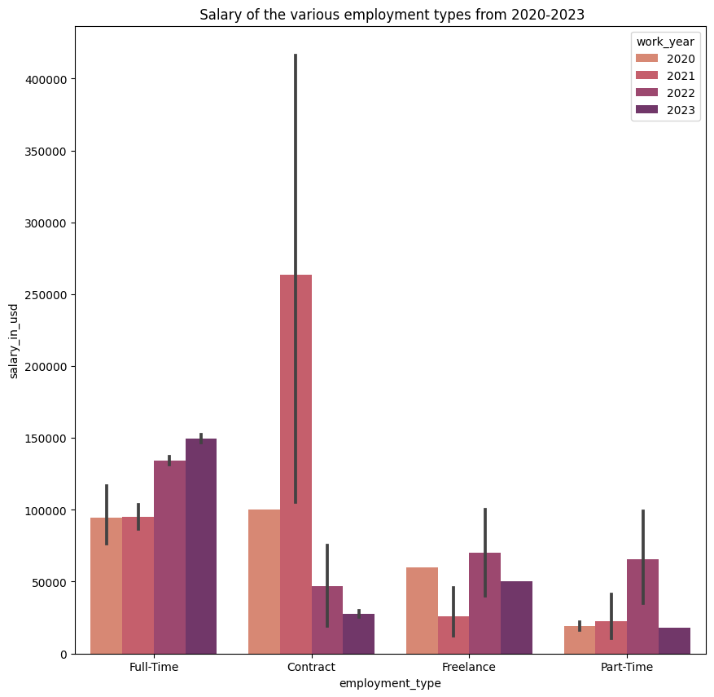

The bar plot represents the salaries of the different employment types from 2020-2023. The graph illustrates that full-time has been steadily increasing throughout the years. However, the salary of contracted employment is sporadic, with a significant increase from an average of 100,000 USD in 2020 to more than 250,000 USD in 2021. As there are only 10 instances of contracted work in the dataset, this employment type must have been important during that year. An explanation for this observation could be that companies were more likely to offer contracted work during lockdown/COVID, instead of full-time, part-time or freelance, as they would be able set the length of employment and save money in the long run. This may explain why there is not much of a salary increase for full-time employees in 2021.

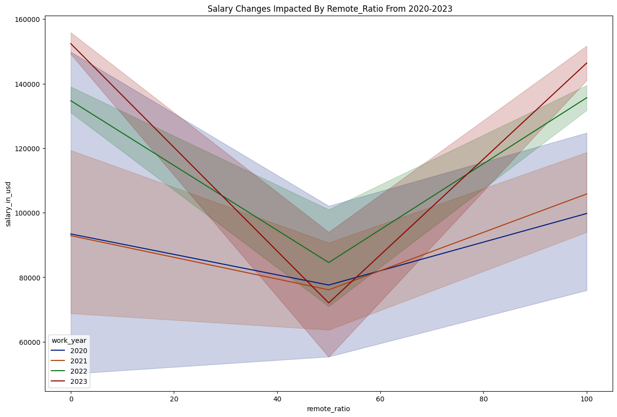

The next variable to explore is the remote_ratio. Fully remote salaries have continually increased throughout the years. In 2020, the average fully remote salary was under 100,000 USD and by 2023 it has risen to over 140,000 USD. Hybrid working had the lowest salaries, with a significant dip in 2023. Moreover, office working/not remote salaries were the highest in 2023. This preference towards office working in the later years could be associated with the fact that office working has returned after the years of lockdown (2020-2022).

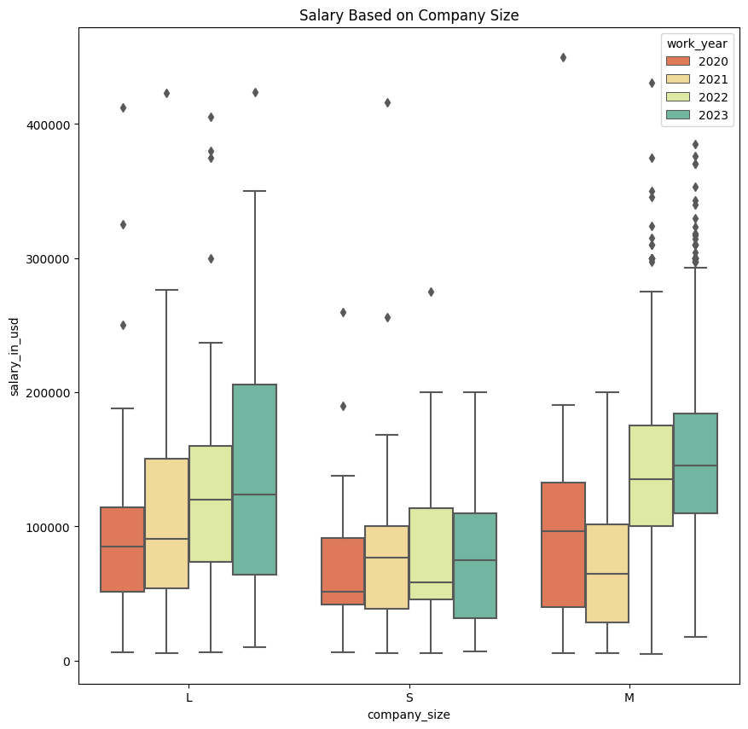

In this boxplot we can see an increase in salaries for large (L) companies from 2020-2023. For medium sized companies, there was a sizable salary increase in 2022-2023 when compared to its previous years. Finally, for small companies (S) there is an increase from 2020-2022. These observations show that data science jobs are becoming increasingly more important to companies, as numbers of professionals and salaries are continuously increasing.

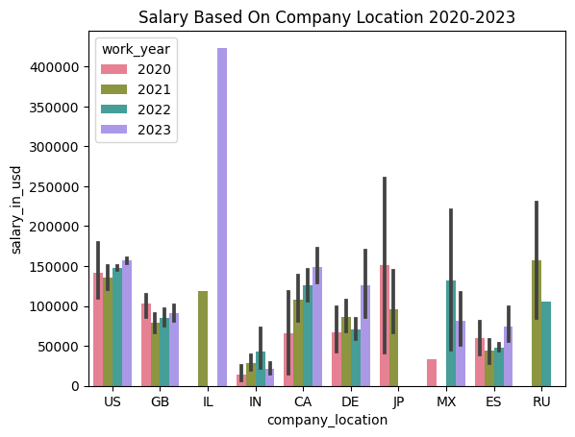

The barplot above described the salaries of data science professionals based on company location. As there are 72 company locations in this dataset, this EDA will only explore the location with the 10 highest salaries. These locations include the United States, Great Britain, Israel, India, Canada, Germany, Japan, Mexico, Spain and Russia .There is a growth in salaries in 2023 for companies based in United States Israel, Canada and Germany indicating for a greater need of data science based jobs. Notably, Canada has seen a steady incline of salary worth thoughout the years. The salaries in Israel in 2023 are the highest of all entries in the dataset, this rise in salary could be due to the growing popularity of the tech sector in the country leasing to more job creation and higher paypackets for professional workers.
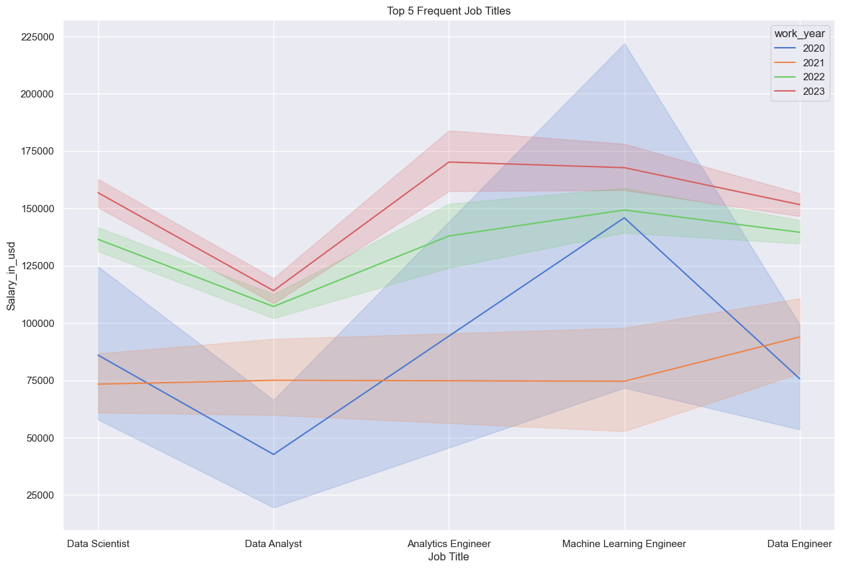

This line graph illustrates that the most frequent or popular jobs to appear in the dataset include Data Scientist, Data Analyst, Analytics Engineer, Machine Learning Engineer and Data Engineer over various experience levels. The Data Analyst and Data Engineer salaries are the only ones of these examples to have increased throughout 2020-2023 demonstrating that these roles are the most sought after by companies. For the other job roles, there is a huge decrease in salary in 2021, especially for the Machine Learning Engineer. In 2022-2023, all the data science roles saw in increase in salaries, with the Analytics Engineer role having the current highest at over 150,000 USD.
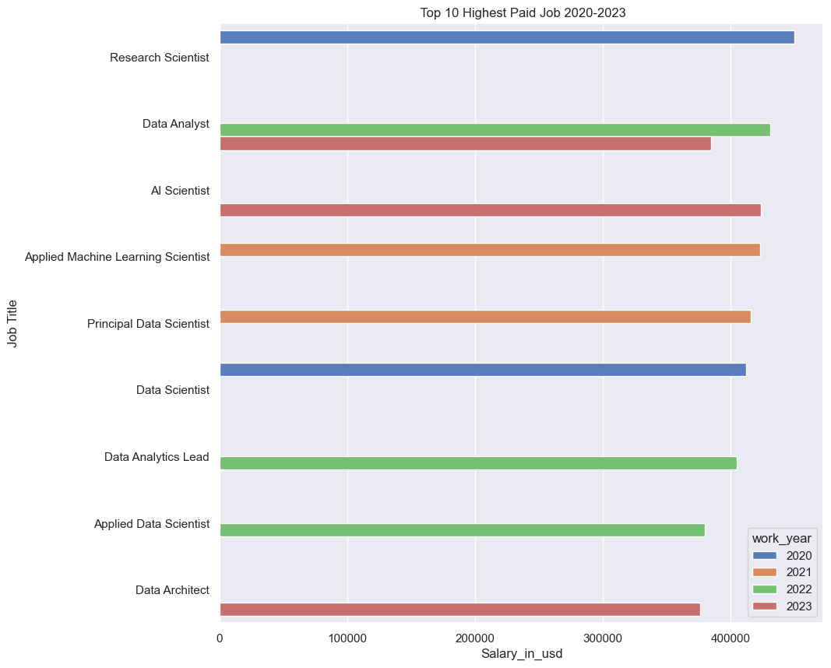

This final bar graph represents the top 10 highest paid salaries in the dataset from 2020-2023. As you can see the Data Analyst role appears twice, having the highest salary in 2022 at 430,967 USD and 385,000 USD in 2023. This reinforces the idea of Data Analysts being one of the most desirable and better paid data science roles in recent years. The highest of the salaries was appointed to the role of Research Scientist in 2020 but the role has not since made in appearance of this list. In 2023, the role of AI Scientist holds the highest salary at 423,834 USD. The interest in AI will see a dramatic increase for companies in 2023 as many recent breakthroughs in AI systems have occurred.

In conclusion, an increase in job opportunity and salaries for Data Science roles is looking very promising, particularly for Data Analysts and AI Scientists. It may be difficult for entry-level individuals to break into the sector as companies appear to currently have a higher proportion of more experienced professionals . This dataset also shows dramatic workplace changes, such as employment types and remote ratios, and salary decreases that occurred between 2020-2022 as previously stated this observation could be explained by the worldwide pandemic.

THIS REPORT WAS WRITTEN BY : Naomi Bouch

